Gym Management System
Report of Major Project One
Submitted in partial fulfillment of the requirement for the award of Degree
Bachelor of Technology
(Computer Science and Engineering & AIML)
Submitted to


RAJIV GANDHI PROUDYOGIKI VISHWAVIDYALAYA BHOPAL (M.P.)

Submitted
by

Arif Iqubal (0192AL221019)

Md Sagir (0192AL221061)

Jeeshan khan (0192AL221045)

Anuj Gupta (0192AL221018)

Under the Guidence of
Prof. Rakesh Kumar Tiwari,


DEPARTMENT OF COMPUTER SCIENCE AND ENGINEERING (AIML)
TECHNOCRATS INSTITUTE OF TECHNOLOGY & SCIENCE, BHOPAL (M.P.)
SESSION: 2025– 2026
TECHNOCRATS INSTITUTE OF TECHNOLOGY & SCIENCE BHOPAL(M.P.)
DEPARTMENT OF COMPUTER SCIENCE AND ENGINEERING (AIML)
CERTIFICATE
This is to certify that the work embodies in this Synopsis entitled “Gym Management System” being submitted by Arif Iqubal (0192AL221019), Md Sagir (0192AL221061), Jeeshan Khan (0192AL221045) and Anuj Gupta (0192AL221018) in partial fulfillment of the requirement for the award of Degree of Bachelor’s of Technology in Computer Science and Engineering & AIML to Rajiv Gandhi Proudyogiki Vishwavidyalaya , Bhopal during the academic year 2025-26 is a record of Bonafide piece of work, carried out by them under my supervision and guidance in the Department of Computer Science and Engineering & AIML, Technocrats Institute of Technology & Science, Bhopal.

Guided By:
Prof. Rakesh Kumar Tiwari

(Head of the Department, Dept. of CSE AIML)

Forwarded by: Approved By:

Prof. Rakesh Kumar Tiwari | Prof. (Dr.) Shashi Kumar Jain
(Head of the Department) | (Director)

TECHNOCRATS INSTITUTE OF TECHNOLOGY & SCIENCE BHOPAL
DEPARTMENT OF COMPUTER SCIENCE AND ENGINEERING & AIML

CERTIFICATE OF APPROVAL

The Project entitled “Gym Management System” being submitted by Arif Iqubal (0192AL221019), Md Sagir (0192AL221061), Jeeshan Khan (0192AL221045) and Anuj Gupta (0192AL221018) has been examined by us and is hereby approved for the award of degree Bachelor of Technology (B.Tech.) in Computer Science & Engineering (AIML) discipline”, for which it has been submitted. It is understood that by this approval the undersigned do not necessarily endorse or approve any statement made, opinion expressed or conclusion drawn there in, but approve the Major Project only for the purpose for which it has been submitted.

Internal Examiner | External Examiner
Date: | Date:

TECHNOCRATS INSTITUTE OF TECHNOLOGY & SCIENCE BHOPAL
DEPARTMENT OF COMPUTER SCIENCE AND ENGINEERING & AIML

DECLARATION

This is Arif Iqubal (0192AL221019), Md Sagir (0192AL221061), Jeeshan Khan (0192AL221045) and Anuj Gupta (0192AL221018) a student of Bachelor of Technology (B.Tech) in Computer Science & Engineering & AIML discipline, session: 2025 - 2026, Technocrats Institute of Technology & Science, Bhopal (M.P.) hereby declare that the work presented in this project entitled “Gym Management System” is the outcome of my own work, is Bonafide and correct to the best of my knowledge and this work has been carried out taking care of Engineering Ethics. The work presented does not infringe any patented work and has not been submitted to any other university or anywhere else for the award of any degree or any professional diploma.

Arif Iqubal (0192AL221019)

Md Sagir (0192AL221061)

Jeeshan khan (0192AL221045)

Anuj Gupta (0192AL221018)
ACKNOWLEDGEMENT

With due respect, we express our deep sense of gratitude to our respected and learned guide Prof. Rakesh Kumar Tiwari Department of Computer Science & Engineering & AIML, TIT & Science, Bhopal, for his valuable help and guidance. We are thankful to him for the encouragement he has given to us in completing this project.
We are also grateful to respected Prof. Rakesh Kumar Tiwari, Head of the Department of Computer Science & Engineering & AIML, Technocrats Institute of Technology & Science, Bhopal and to respected Dr. Shashi Kumar Jain, Director, TIT& Science, Bhopal, for permitting us to utilize all the necessary facilities of the college.
We are also thankful to our guide for their kind co-operation and suggesting improvements in project.
We are also thankful to all the other staff members of our department for their kind co- operation and suggesting improvements in project.
We would like to express our deep appreciation towards our classmates for providing as much needed suggestions and cordial atmosphere.
Last but not the least we would like to thank our family members for their support and encouragement without which this Major Project would not have been completed.

Arif Iqubal (0192AL221019)

Md Sagir (0192AL221061)

Jeeshan khan (0192AL221045)

Anuj Gupta (0192AL221018)
Abstract
The Gym Management System is a mobile-based application developed to automate and streamline the daily operations of a gym or fitness center. Traditional gym management relies heavily on manual record keeping, which is time-consuming, error-prone, and inefficient. This project provides a digital solution for managing member registration, attendance tracking, monthly subscriptions, payment records, dues management, workout plans, and overall financial summaries.
The application is developed using React Native for cross-platform mobile compatibility and Firebase as the backend service for authentication, real-time database management, and secure data storage. The system enables gym administrators to efficiently manage member details, track attendance on a daily basis, generate monthly and yearly financial reports, and monitor outstanding dues. Members benefit from organized records, transparency in payments, and improved service quality.
The proposed system enhances operational efficiency, reduces paperwork, improves data accuracy, and ensures secure handling of gym-related information. This project demonstrates how modern mobile and cloud technologies can be effectively utilized to build scalable and user-friendly management solutions for fitness centers.

Table of Contents
Certificates ........................................................................ i
Certificate of Approval ............................................................ ii
Declaration ......................................................................... iii
Acknowledgement ................................................................. iv
Abstract ............................................................................... v

CHAPTER 1 – INTRODUCTION ........................................ 13
1.1 Overview of the Project ..................................................... 13
1.2 Problem Statement .......................................................... 13
1.3 Objectives of the Project .................................................. 13
1.4 Scope of the Project .......................................................... 13

CHAPTER 2 – MOTIVATION ........................................... 14
2.1 Existing System ............................................................... 14
2.2 Drawbacks of Existing System ............................................. 14
2.3 Proposed System ............................................................. 14
2.4 Advantages of Proposed System ......................................... 14
2.5 Motivation for Choosing the Project ..................................... 14

CHAPTER 3 – FACILITIES REQUIRED ............................... 14–17
3.1 Hardware Requirements .................................................. 14
3.2 Software Requirements .................................................. 14
3.3 Development Environment ............................................... 15
3.4 Technology Stack Description .......................................... 15
3.5 Feasibility Study ............................................................ 15
3.5.1 Technical Feasibility ................................................ 15
3.5.2 Economic Feasibility ................................................ 15
3.5.3 Operational Feasibility .............................................. 16
3.6 Constraints of the System ................................................ 16
3.7 Assumptions Made .......................................................... 16
3.8 Standards Followed .......................................................... 16
3.9 System Resource Utilization ............................................. 16
3.10 Data Storage Requirements ........................................... 16
3.11 Network Requirements .................................................. 16
3.12 User Skill Requirements ................................................ 16
3.13 Maintenance Requirements ............................................ 17
3.14 Risk Analysis ................................................................. 17
3.15 Summary of Facilities Required ....................................... 17

CHAPTER 4 – METHODOLOGY / TECHNICAL DETAILS ......... 17–21
4.1 Introduction to Methodology ............................................. 17
4.2 Software Development Life Cycle Model Used ................. 17
4.3 System Architecture .......................................................... 17
4.4 Functional Modules of the System .................................... 18
4.4.1 Admin Authentication Module ..................................... 18
4.4.2 Dashboard Module ..................................................... 18
4.4.3 Member Management Module .................................... 18
4.4.4 Attendance Management Module ............................... 18
4.4.5 Payment and Transaction Module .............................. 19
4.4.6 Membership Plan Module .......................................... 19
4.4.7 Notification and Reminder Module ............................. 19
4.5 Database Design .............................................................. 19
4.6 Entity Relationship Description ........................................ 19
4.7 Data Flow Diagram Description ........................................ 20
4.8 Algorithm Design .............................................................. 20
4.9 Security Mechanisms ......................................................... 20
4.10 Error Handling Mechanism ............................................. 20
4.11 Testing Strategy .............................................................. 20
4.12 Performance Analysis ..................................................... 21
4.13 Deployment Methodology .............................................. 21
4.14 Limitations of Methodology ............................................ 21
4.15 Advantages of Adopted Methodology ............................. 21
4.16 Summary of Methodology .............................................. 21

CHAPTER 5 – OUTPUT / RESULTS ................................. 21–24
5.1 Introduction ................................................................. 21
5.2 User Authentication Output ............................................ 21
5.3 Dashboard Output .......................................................... 22
5.4 Member Registration Output ........................................... 22
5.5 Member Management Output ......................................... 22
5.6 Attendance Management Output .................................... 23
5.7 Payment and Transaction Output ................................... 23
5.8 Membership Plan Output ................................................ 23
5.9 Reports and Summary Output ......................................... 24
5.10 Performance Evaluation .............................................. 24
5.11 User Interface Evaluation ............................................ 24
5.12 Accuracy and Reliability Analysis .................................. 24
5.13 Error Handling Output ................................................. 24
5.14 Limitations Observed .................................................... 24
5.15 Summary of Results .................................................... 24

CHAPTER 6 – CONCLUSION ........................................ 25-26
6.1 Project Summary .......................................................... 25
6.2 Achievement of Objectives ............................................. 25
6.3 System Performance and Reliability ................................. 25
6.4 Benefits of the Implemented System ............................... 25
6.5 Limitations of the System ............................................... 25
6.6 Learning Outcomes ....................................................... 25
6.7 Final Remarks .............................................................. 25

CHAPTER 7 – FUTURE SCOPE ......................................26–27
7.1 Introduction ................................................................. 26
7.2 Member-Side Mobile Application .................................... 26
7.3 Online Payment Gateway Integration .............................. 26
7.4 Biometric and QR-Based Attendance System ................. 26
7.5 AI-Based Workout and Diet Recommendations ............. 27
7.6 Advanced Analytics and Reporting ................................. 27
7.7 Multi-Branch Gym Management .................................... 27
7.8 Cloud Scalability and Performance Optimization ........... 27
7.9 Enhanced Security Features ......................................... 27
7.10 Integration with Wearable Devices ............................... 27
7.11 Offline Functionality .................................................. 27
7.12 Commercial Deployment Potential ............................... 27
7.13 Summary of Future Scope ........................................... 27

REFERENCES ............................................................ 27

APPENDICES ............................................................ 28–36
Appendix I – System Screenshots and Description ............... 28-34
Appendix II – Database Structure Description ..................... 35
Appendix III – Sample Algorithms ...................................... 35
Appendix IV – Test Case Summary ..................................... 36
Appendix V – Summary of Appendices ................................. 36

CHAPTER 1: INTRODUCTION
1.1 Overview of the Project
In the modern digital era, information technology plays a crucial role in improving efficiency and accuracy in every sector. Fitness centers and gyms are no exception. With the increasing number of gym members and competitive fitness industry, maintaining records manually has become impractical and inefficient. The Gym Management System (GMS) is designed to automate and digitize the entire process of gym administration.
This project focuses on developing a mobile-based Gym Management System that helps gym owners and administrators manage daily activities such as member registration, attendance tracking, subscription management, payment collection, due tracking, and financial reporting. The system is developed using React Native, which enables cross-platform mobile application development, and Firebase, which provides cloud-based backend services.
The proposed system aims to reduce paperwork, improve data accuracy, ensure secure storage of sensitive information, and provide real-time access to gym data. By adopting this system, gym administrators can focus more on customer satisfaction and service quality rather than administrative overhead.
1.2 Problem Statement
Traditional gym management systems rely heavily on manual record-keeping using registers or spreadsheets. These approaches suffer from several limitations such as data inconsistency, difficulty in searching records, lack of data security, and high chances of human error. Managing attendance, tracking monthly fees, calculating dues, and generating reports become tedious and time-consuming tasks.
As the number of members increases, manual systems fail to scale effectively. There is also no centralized system to manage historical data, making it difficult to analyze trends or generate financial summaries. Hence, there is a strong need for an automated Gym Management System that ensures reliability, scalability, and efficiency.
1.3 Objectives of the Project
The primary objectives of the Gym Management System are as follows:
- To design and develop a user-friendly mobile application for gym administration
- To automate member registration and profile management
- To provide an efficient attendance tracking mechanism
- To manage monthly subscriptions, payments, and dues
- To generate accurate financial reports and summaries
- To ensure data security and integrity using cloud technologies
1.4 Scope of the Project
The scope of this project includes the development of an admin-centric mobile application that manages all gym-related operations. The system supports real-time data updates, secure authentication, and cloud storage. However, the project does not include biometric attendance or wearable device integration in its current version.

CHAPTER 2: MOTIVATION
2.1 Existing System
In many small and medium-sized gyms, administrative tasks are carried out manually. Member details, attendance records, and payment information are stored in physical registers or basic spreadsheet files. These systems lack automation and require continuous manual effort to update and maintain records.
2.2 Drawbacks of Existing System
The existing manual or semi-automated systems have several disadvantages:
- High dependency on paperwork
- Increased chances of data loss or damage
- Difficulty in maintaining historical records
- Lack of data security and privacy
- No real-time access to information
- Time-consuming report generation
2.3 Proposed System
The proposed Gym Management System provides a digital solution by using a mobile application integrated with a cloud backend. All gym operations are managed through a centralized platform, enabling real-time updates and secure data handling.
2.4 Advantages of Proposed System
- Reduction in manual work
- Improved accuracy and efficiency
- Secure cloud-based data storage
- Easy access to records anytime and anywhere
- Scalability to handle large number of members
2.5 Motivation for Choosing the Project
The motivation behind selecting this project arises from the growing demand for digital solutions in the fitness industry. This project offers practical exposure to mobile application development, cloud computing, and database management while addressing a real-world problem.

CHAPTER 3: FACILITIES REQUIRED
3.1 Hardware Requirements
The hardware requirements for developing and running the Gym Management System are minimal and cost-effective:
- Android smartphone for testing
- Computer system with minimum Intel i5 processor
- Minimum 8 GB RAM
- Stable internet connection
3.2 Software Requirements
The Gym Management System is developed using modern, reliable, and widely adopted software technologies to ensure scalability, security, and ease of maintenance. The software requirements are carefully selected to support cross-platform development and cloud-based operations.
- Operating System: Windows 10 or above / macOS / Linux
- Programming Language: JavaScript
- Frontend Framework: React Native
- Backend Services: Firebase
- Database: Firebase Firestore (NoSQL)
- Authentication: Firebase Authentication (Email & Password)
- Development Environment: Node.js Runtime Environment
- Testing Platform: Android Emulator / Physical Android Device
These software tools collectively provide a robust environment for developing, testing, and deploying the Gym Management System.

3.3 Development Environment
The development environment is a critical component in the successful implementation of the Gym Management System. A well-configured development environment ensures smooth coding, testing, debugging, and deployment of the application. For this project, a modern and efficient development setup has been used to support mobile application development and cloud integration.
Visual Studio Code (VS Code) is used as the primary code editor due to its lightweight nature, fast performance, and extensive support for extensions. Features such as syntax highlighting, IntelliSense, debugging tools, and Git integration significantly enhance developer productivity. VS Code also supports React Native development efficiently through dedicated extensions.
Node.js is installed to manage project dependencies and execute JavaScript-based development tools. The Node Package Manager (NPM) is used to install and manage required libraries and frameworks.
Expo CLI is utilized to simplify the development and testing of the React Native application. Expo allows real-time preview of the application on physical devices without complex build processes. Hot reloading features help developers instantly view changes, reducing development time.
Android Studio is used to run Android emulators for testing the application under different screen sizes and hardware configurations. Testing on emulators ensures application compatibility across multiple devices.
Version control is managed using Git, and project repositories are maintained on GitHub to enable collaborative development, track changes, and maintain code history.

3.4 Technology Stack Description
The technology stack selected for the Gym Management System is chosen to ensure scalability, security, performance, and ease of maintenance.
Frontend Technology – React Native:
React Native is a popular open-source framework used to build mobile applications using JavaScript and React. It allows developers to create cross-platform applications using a single codebase. This reduces development effort and ensures consistency across platforms.
Backend Technology – Firebase:
Firebase is a Backend-as-a-Service (BaaS) platform provided by Google. It eliminates the need for setting up and managing custom backend servers. Firebase provides authentication, database management, cloud storage, and security features.
Database – Firebase Firestore:
Firestore is a NoSQL cloud database that stores data in documents and collections. It supports real-time synchronization and offline data access. Firestore is highly scalable and suitable for applications with dynamic data structures.
Authentication – Firebase Authentication:
Firebase Authentication provides secure user login mechanisms using email and password. It ensures encrypted storage of credentials and prevents unauthorized access.
This technology stack ensures that the Gym Management System is robust, efficient, and future-ready.

3.5 Feasibility Study
A feasibility study is conducted to evaluate the practicality of developing and implementing the proposed Gym Management System. The feasibility analysis ensures that the project is viable from technical, economic, and operational perspectives.
3.5.1 Technical Feasibility
The project is technically feasible as it uses well-established and widely supported technologies. React Native and Firebase are mature platforms with extensive documentation and community support. The system does not require high-end hardware or complex infrastructure, making it suitable for implementation in real-world gym environments.
3.5.2 Economic Feasibility
The project is economically feasible as it uses open-source tools and free-tier cloud services. Firebase offers generous free usage limits, which are sufficient for small and medium-sized gyms. No additional cost is required for servers, database management, or security infrastructure, reducing overall development and deployment costs.

3.5.3 Operational Feasibility
The system is operationally feasible as it is designed to be user-friendly and intuitive. Gym administrators can easily learn to operate the application with minimal training. The mobile-based interface allows staff to manage gym operations efficiently without technical expertise.

3.6 Constraints of the System
Despite its advantages, the Gym Management System has certain constraints:
- The system requires a stable internet connection for real-time data synchronization.
- Offline functionality is limited.
- Performance may depend on the quality of the user’s device.
- The system is admin-centric and does not currently include a separate member login module.
These constraints are considered acceptable given the scope of the project.

3.7 Assumptions Made
The following assumptions are considered during the development of the system:
- Gym administrators have basic knowledge of smartphone usage.
- Accurate data is entered by authorized personnel.
- Internet connectivity is available during operational hours.
- The gym follows a monthly subscription-based membership model.
These assumptions help define the system boundaries and simplify development.

3.8 Standards Followed
The project follows standard software engineering principles throughout the development lifecycle. Modular design is adopted to improve maintainability and scalability. Proper coding standards, naming conventions, and documentation practices are followed to ensure readability and ease of future enhancement.
The application design follows usability standards to ensure simple navigation and minimal user confusion. Data security and privacy standards are maintained using Firebase authentication and access control rules.

3.9 System Resource Utilization
The Gym Management System is optimized to efficiently utilize system resources such as memory, processing power, and network bandwidth. Lightweight components and optimized database queries ensure smooth performance even on low-end devices. Firestore’s real-time capabilities reduce unnecessary data fetching and improve responsiveness.

3.10 Data Storage Requirements
The system stores various types of data including member profiles, attendance records, transaction details, and subscription plans. All data is stored securely in the cloud using Firebase Firestore. The NoSQL structure allows flexible schema design, enabling easy modifications and future expansion without affecting existing data.
Regular backups and redundancy mechanisms provided by Firebase ensure data reliability and availability.

3.11 Network Requirements
A reliable internet connection is essential for the proper functioning of the system. The application is optimized to operate under low bandwidth conditions by minimizing network calls and efficiently handling data synchronization.

3.12 User Skill Requirements
The system is designed to be operated by non-technical users. Basic smartphone handling skills are sufficient to use the application. Clear labels, simple navigation, and structured layouts help reduce the learning curve.

3.13 Maintenance Requirements
System maintenance includes periodic updates, bug fixes, and feature enhancements. Since Firebase manages backend infrastructure, server-side maintenance is minimal. Updates can be deployed easily through application version control and distribution mechanisms.

3.14 Risk Analysis
Potential risks associated with the system include data entry errors, internet outages, and unauthorized access attempts. These risks are mitigated through data validation, authentication mechanisms, and secure cloud storage.

3.15 Summary of Facilities Required
This chapter discussed the hardware, software, development environment, technology stack, feasibility aspects, constraints, and operational requirements necessary for the successful implementation of the Gym Management System. The selected facilities ensure that the system is cost-effective, scalable, secure, and suitable for real-world deployment.

CHAPTER 4: METHODOLOGY / TECHNICAL DETAILS
4.1 Introduction to Methodology
Methodology refers to the systematic approach followed to design, develop, implement, and evaluate the Gym Management System. This chapter explains the step-by-step process adopted during the project development lifecycle. A well-defined methodology ensures that the project objectives are achieved efficiently while maintaining quality, reliability, and scalability.
The development of the Gym Management System follows a structured approach starting from requirement analysis to final testing and deployment. The methodology includes system analysis, architectural design, module identification, database design, implementation strategy, security mechanisms, and testing procedures. Each phase is carefully planned and executed to ensure smooth functioning of the system.

4.2 Software Development Life Cycle (SDLC) Model Used
The Incremental Model of the Software Development Life Cycle (SDLC) is adopted for this project. The incremental model allows the system to be developed in smaller modules, where each module is designed, implemented, and tested individually before integrating into the complete system.
Reasons for Choosing Incremental Model
- Allows early delivery of working modules
- Easier to detect and fix errors
- Supports continuous feedback and improvement
- Suitable for medium-scale applications
- Reduces development risk
Each increment in the Gym Management System adds new functionality such as member management, attendance tracking, payment handling, and reporting.

4.3 System Architecture
The Gym Management System follows a Client–Server Architecture integrated with cloud services.
Architecture Overview
- Client Layer:
Mobile application developed using React Native
- Application Layer:
Business logic and UI components
- Backend Layer:
Firebase Authentication and Firestore Database
The mobile application interacts with Firebase services over the internet. Firebase handles authentication, data storage, and security rules, eliminating the need for a separate backend server.
Advantages of the Architecture
- Scalability
- High availability
- Real-time data synchronization
- Reduced infrastructure cost
- Secure access control

4.4 Functional Modules of the System
The Gym Management System is divided into multiple modules to simplify development and maintenance.

4.4.1 Admin Authentication Module
This module ensures secure access to the system. Only authorized gym administrators can log in using valid credentials.
Functions:
- Admin login using email and password
- Credential verification using Firebase Authentication
- Secure session handling
- Logout functionality
This module prevents unauthorized access and protects sensitive gym data.

4.4.2 Dashboard Module
The dashboard acts as the central control panel for the administrator.
Features:
- Total number of members
- Active and inactive memberships
- Monthly income summary
- Pending dues overview
- Quick navigation to other modules
The dashboard provides a real-time overview of gym operations, enabling informed decision-making.

4.4.3 Member Management Module
This module manages all member-related activities.
Functions:
- Add new members
- Edit member details
- Delete inactive members
- Assign membership plans
- Store contact and personal information
Each member is assigned a unique identifier to ensure accurate tracking.

4.4.4 Attendance Management Module
Attendance tracking is a core feature of the system.
Functions:
- Daily attendance marking
- Automatic date and time recording
- Member-wise attendance history
- Monthly attendance reports
Attendance data is stored in Firestore and updated in real time.

4.4.5 Payment and Transaction Module
This module manages all financial activities.
Functions:
- Record monthly payments
- Track pending dues
- Generate transaction history
- Monthly and yearly income calculation
Automated calculations reduce human error and improve accuracy.

4.4.6 Membership Plan Module
This module manages different gym plans.
Features:
- Monthly, quarterly, and yearly plans
- Plan pricing
- Duration management
- Assignment to members
This flexibility allows gyms to offer customized plans.

4.4.7 Notification and Reminder Module
The system can generate reminders for:
- Pending payments
- Membership expiry
- Monthly renewals
This improves communication and reduces missed payments.

4.5 Database Design
The Gym Management System uses Firebase Firestore, a NoSQL cloud database.
Database Structure
Firestore stores data in collections and documents.
Major Collections:
- Admins
- Members
- Attendance
- Transactions
- MembershipPlans
Advantages of Firestore
- Real-time updates
- Flexible schema
- High scalability
- Automatic backup

4.6 Entity Relationship Description
Although Firestore is NoSQL, logical entity relationships exist.
- One admin manages multiple members
- One member can have multiple attendance records
- One member can have multiple transactions
- One membership plan can be assigned to many members
These relationships help in data organization and retrieval.

4.7 Data Flow Diagram (DFD) Description
DFD Level 0
The Level 0 DFD represents the system as a single process interacting with external entities such as the Admin and Firebase Database.
DFD Level 1
The Level 1 DFD breaks the system into sub-processes:
- Authentication
- Member Management
- Attendance Processing
- Payment Processing
Data flows between these processes and the database.

4.8 Algorithm Design
4.8.1 Attendance Marking Algorithm
- Select member
- Select date
- Mark present/absent
- Store record in database
4.8.2 Payment Due Calculation Algorithm
- Retrieve membership plan
- Check last payment date
- Compare with current date
- Calculate pending dues
These algorithms ensure automation and consistency.

4.9 Security Mechanisms
Security is implemented using Firebase Authentication and Firestore Security Rules.
Security Features
- Encrypted authentication
- Role-based access control
- Restricted database access
- Secure cloud storage
Only authenticated admins can access or modify data.

4.10 Error Handling Mechanism
The system includes error handling to manage:
- Invalid login credentials
- Network failures
- Missing data fields
- Database access errors
User-friendly error messages improve usability.

4.11 Testing Strategy
Testing ensures system reliability and correctness.
4.11.1 Unit Testing
Each module is tested individually.
4.11.2 Integration Testing
Modules are tested together to ensure smooth interaction.
4.11.3 System Testing
The complete system is tested under real-world scenarios.

4.12 Performance Analysis
The application demonstrates:
- Fast response time
- Efficient database queries
- Low memory usage
- Smooth UI performance
Firestore real-time sync enhances performance.

4.13 Deployment Methodology
The application is deployed using Expo build tools.
Steps:
- Code finalization
- Build generation
- Testing on real devices
- Release deployment
Firebase backend requires no manual deployment.

4.14 Limitations of Methodology
- Internet dependency
- No offline-first architecture
- No biometric authentication
These limitations are acceptable within project scope.

4.15 Advantages of Adopted Methodology
- Modular development
- Easy maintenance
- Scalability
- Reduced risk

4.16 Summary of Methodology
This chapter detailed the systematic methodology followed in developing the Gym Management System. From architecture design to deployment, each phase was carefully executed to ensure a secure, efficient, and scalable system. The adopted methodology ensures that the application meets functional requirements and is suitable for real-world gym management operations.

CHAPTER 5: OUTPUT / RESULTS
5.1 Introduction
This chapter presents the output and results obtained after implementing the Gym Management System. The performance of the system is evaluated based on functionality, usability, accuracy, and efficiency. The outputs demonstrate how the developed application successfully meets the objectives defined in earlier chapters.
The Gym Management System was tested under real-time conditions by performing operations such as member registration, attendance marking, payment recording, and report generation. The results confirm that the system operates efficiently and provides accurate information with minimal user effort.

5.2 User Authentication Output
The authentication module is the first point of interaction between the user and the system.
Description
- Admin enters registered email ID and password
- Credentials are verified using Firebase Authentication
- On successful login, admin is redirected to the dashboard
- On failure, an error message is displayed
Result Obtained
The system successfully restricts access to authorized users only. Invalid login attempts are handled gracefully with appropriate error messages.
Outcome:
- Secure login achieved
- Unauthorized access prevented
- Improved system security

5.3 Dashboard Output
The dashboard screen provides a summarized view of gym operations.
Features Displayed
- Total number of registered members
- Active and inactive memberships
- Monthly income summary
- Pending payment dues
- Navigation shortcuts to modules
Result Obtained
The dashboard loads quickly and displays real-time data fetched from Firebase Firestore. It allows administrators to monitor gym performance at a glance.
Outcome:
- Real-time data visualization
- Improved decision-making
- Reduced manual calculations

5.4 Member Registration Output
The member registration module enables administrators to add new gym members.
Input Details
- Member name
- Age and gender
- Contact number
- Address
- Membership plan
- Joining date
Process
- Admin fills in the registration form
- Data is validated
- Member record is stored in Firestore
Result Obtained
The system successfully stores member details in the database and assigns a unique identifier to each member.
Outcome:
- Accurate data storage
- Elimination of paper-based records
- Easy retrieval and modification of member information

5.5 Member Management Output
This module allows updating and deleting member records.
Operations Performed
- Edit member profile
- Update contact details
- Change membership plan
- Remove inactive members
Result Obtained
All updates are reflected instantly in the database and dashboard.
Outcome:
- Real-time data synchronization
- Improved data consistency
- Efficient member management

5.6 Attendance Management Output
Attendance tracking is a core functional output of the system.
Process
- Admin selects date
- Selects member
- Marks attendance (Present/Absent)
- Attendance stored in database
Result Obtained
Attendance records are saved accurately with date and time stamps. The system allows viewing daily and monthly attendance reports.
Outcome:
- Automated attendance tracking
- Accurate historical records
- Reduced manual errors

5.7 Payment and Transaction Output
The payment module manages all financial records.
Operations Performed
- Monthly fee entry
- Due calculation
- Transaction history generation
- Monthly income summary
Result Obtained
The system automatically calculates dues and updates payment status. Transaction history is maintained member-wise.
Outcome:
- Accurate financial records
- Improved transparency
- Easy tracking of pending payments

5.8 Membership Plan Output
This module manages gym membership plans.
Features
- Create new plans
- Modify existing plans
- Assign plans to members
Result Obtained
Plan assignment and pricing are handled efficiently. Changes in plan details are reflected automatically in member records.
Outcome:
- Flexible plan management
- Easy plan customization
- Improved membership handling

5.9 Reports and Summary Output
The system generates multiple reports.
Reports Generated
- Daily attendance report
- Monthly income report
- Member-wise payment report
- Pending dues report
Result Obtained
Reports are generated instantly based on real-time data.
Outcome:
- Time-saving report generation
- Accurate summaries
- Better financial analysis

5.10 Performance Evaluation
The system performance was evaluated based on response time, accuracy, and resource usage.
Observations
- Fast data retrieval from Firestore
- Smooth UI performance
- Minimal memory consumption
- Stable performance across devices
Result:
The system performs efficiently even with increasing data volume.

5.11 User Interface Evaluation
The UI is designed with simplicity and usability in mind.
Evaluation Criteria
- Ease of navigation
- Clear labels and buttons
- Consistent design
- Responsive layout
Result Obtained
Users found the interface intuitive and easy to use with minimal training.

5.12 Accuracy and Reliability Analysis
The system maintains high accuracy in:
- Attendance records
- Payment calculations
- Member data storage
Firebase ensures data integrity and reliability through cloud-based storage.

5.13 Error Handling Output
The system handles errors such as:
- Invalid login credentials
- Missing input fields
- Network issues
User-friendly messages are displayed without crashing the application.

5.14 Limitations Observed During Output Evaluation
- Internet dependency affects real-time updates
- No offline attendance support
- Manual data entry required
These limitations are acceptable within the defined scope of the project.

5.15 Summary of Results
The output results clearly demonstrate that the Gym Management System successfully fulfills its intended objectives. The system automates gym operations, reduces administrative workload, improves data accuracy, and enhances overall efficiency. The results validate the effectiveness of the chosen methodology and technology stack.

CHAPTER 6: CONCLUSION
6.1 Project Summary
The Gym Management System project was undertaken with the objective of designing and developing an efficient, reliable, and user-friendly digital solution for managing gym operations. Traditional gym management practices rely heavily on manual record keeping, which often leads to inefficiency, data inconsistency, and increased administrative workload. This project successfully addresses these issues by providing an automated mobile-based system that streamlines gym administration.
The system was developed using React Native for the frontend and Firebase as the backend service. The choice of these technologies enabled the development of a scalable, secure, and cross-platform application. The system integrates key functionalities such as member registration, attendance management, payment tracking, membership plan management, and report generation into a single centralized platform.

6.2 Achievement of Objectives
All the objectives defined at the beginning of the project were successfully achieved. The system automates gym operations, reduces dependency on paperwork, and improves data accuracy. The member management module allows easy addition, modification, and deletion of member records. The attendance management module provides accurate daily and monthly attendance tracking. The payment module ensures proper handling of financial transactions and dues.
The system also provides real-time data synchronization using Firebase Firestore, enabling administrators to access up-to-date information at any time. The dashboard module offers a comprehensive overview of gym activities, helping administrators make informed decisions.

6.3 System Performance and Reliability
The Gym Management System demonstrated satisfactory performance during testing and evaluation. The application showed quick response times, smooth user interface interactions, and reliable data storage. Firebase’s cloud infrastructure ensured high availability and data consistency.
The use of real-time database features allowed instant updates across modules, improving system responsiveness. Error handling mechanisms and validation checks ensured that incorrect data entries were minimized, enhancing system reliability.

6.4 Benefits of the Implemented System
The implemented system offers several benefits over traditional manual systems:
- Reduction in administrative workload
- Improved accuracy and consistency of records
- Secure storage of sensitive data
- Faster access to information
- Easy report generation
- Scalability for future expansion
These benefits make the Gym Management System a practical and valuable solution for fitness centers of varying sizes.

6.5 Limitations of the System
Despite its advantages, the system has certain limitations. It requires a stable internet connection for real-time data access, as it is cloud-based. Offline functionality is limited, and all data entry operations must be performed manually by the administrator. Additionally, the current version of the system is admin-centric and does not provide a separate interface for gym members.
These limitations are acceptable within the scope of the project and provide opportunities for future enhancement.

6.6 Learning Outcomes
This project provided valuable learning experiences in multiple domains. It enhanced understanding of mobile application development using React Native and cloud backend integration using Firebase. The project also strengthened knowledge of software engineering principles, database design, authentication mechanisms, and real-time data handling.
Working on this project improved problem-solving skills, teamwork, and project management abilities. It also offered hands-on experience in developing a real-world application from concept to implementation.

6.7 Final Remarks
In conclusion, the Gym Management System successfully fulfills the requirements of a modern gym administration platform. It demonstrates the effective use of mobile and cloud technologies to solve real-world problems. The project stands as a practical, efficient, and scalable solution that can be further enhanced to meet evolving needs in the fitness industry.
The successful completion of this project reflects the effective application of theoretical knowledge into practical implementation and serves as a strong foundation for future advancements in software development.

CHAPTER 7: FUTURE SCOPE
7.1 Introduction
The Gym Management System developed in this project provides an effective and reliable solution for automating gym operations. However, software systems are never static and must evolve continuously to meet changing user requirements and technological advancements. This chapter discusses the potential enhancements and future improvements that can be incorporated into the system to make it more robust, feature-rich, and scalable.
The future scope of the Gym Management System focuses on improving functionality, user experience, security, and analytical capabilities. These enhancements can significantly increase the system’s usability and adoption in large-scale fitness centers.

7.2 Member-Side Mobile Application
Currently, the system is designed primarily for administrative use. In the future, a separate member-side mobile application can be developed. This application would allow gym members to:
- View their attendance history
- Check membership validity
- Track payment status and dues
- Receive workout schedules and diet plans
- Get notifications and reminders
Providing member access will improve transparency and enhance customer engagement.

7.3 Online Payment Gateway Integration
Future versions of the system can integrate secure online payment gateways such as UPI, debit/credit cards, and net banking. This will allow members to make payments directly through the application, reducing the need for manual payment entries.
Online payment integration will improve convenience, reduce cash handling, and ensure accurate transaction records.

7.4 Biometric and QR-Based Attendance System
Attendance tracking can be further enhanced by integrating biometric authentication or QR code-based attendance systems. This will:
- Prevent proxy attendance
- Improve accuracy
- Reduce manual effort
Such advanced attendance mechanisms are especially useful for large gyms with high daily footfall.

7.5 AI-Based Workout and Diet Recommendations
Artificial Intelligence (AI) can be incorporated to provide personalized workout and diet plans based on member profiles, fitness goals, age, and medical history. AI-driven recommendations can help members achieve better fitness outcomes and increase satisfaction.

7.6 Advanced Analytics and Reporting
The system can be enhanced with advanced analytics features to provide deeper insights into gym operations. Future analytics modules may include:
- Member retention analysis
- Peak usage hours
- Revenue growth trends
- Attendance pattern analysis
Graphical reports and dashboards can assist gym owners in strategic decision-making.

7.7 Multi-Branch Gym Management
Future enhancements can support multi-branch gym management, allowing gym chains to manage multiple branches from a single application. This feature will enable centralized data management and branch-wise performance comparison.

7.8 Cloud Scalability and Performance Optimization
As the number of users increases, the system can be optimized further to handle higher data volumes and concurrent users. Cloud scalability features can be implemented to ensure consistent performance and availability.

7.9 Enhanced Security Features
Additional security measures such as two-factor authentication (2FA), role-based access control, and advanced encryption techniques can be implemented to further strengthen data security and user privacy.

7.10 Integration with Wearable Devices
The system can be extended to integrate with wearable fitness devices and smartwatches. This integration will allow automatic tracking of workout data, calories burned, and fitness progress.

7.11 Offline Functionality
Future versions can include limited offline functionality, allowing data entry without internet connectivity. Data can be synchronized automatically when the connection is restored.

7.12 Commercial Deployment Potential
With further enhancements, the Gym Management System can be converted into a commercial product or Software-as-a-Service (SaaS) platform. This opens opportunities for monetization and real-world deployment across multiple fitness centers.

7.13 Summary of Future Scope
The future scope of the Gym Management System is vast and promising. By incorporating advanced technologies such as AI, analytics, online payments, and biometric systems, the application can evolve into a comprehensive fitness management platform. These enhancements will not only improve operational efficiency but also enhance user experience and business growth.

References
- React Native Official Documentation
- Firebase Documentation
- Software Engineering – Pressman
- Mobile Application Development Resources

APPENDICES

**APPENDIX – I
SYSTEM SCREENSHOTS AND DESCRIPTION**
This appendix provides supplementary information related to the implementation of the Gym Management System. The screenshots and explanations included here support the functionality discussed in earlier chapters and help in better understanding of the system operation. Including these details in the appendix avoids cluttering the main chapters while still providing complete technical documentation.

A.1 Login Screen
The Login Screen is the entry point of the Gym Management System. It ensures that only authorized administrators can access the system.
Description:
- The screen contains input fields for email ID and password.
- Firebase Authentication is used to validate the credentials.
- Error messages are displayed for invalid login attempts.
- On successful login, the user is redirected to the dashboard.
Purpose:
- Ensures system security
- Prevents unauthorized access


(Screenshot: Login Screen)

A.2 Dashboard Screen
The Dashboard provides a summarized view of gym activities and statistics.
Description:
- Displays total number of members
- Shows active and inactive memberships
- Monthly income summary
- Pending dues information
- Navigation buttons to other modules
Purpose:
- Provides quick overview of gym performance
- Enables faster decision-making
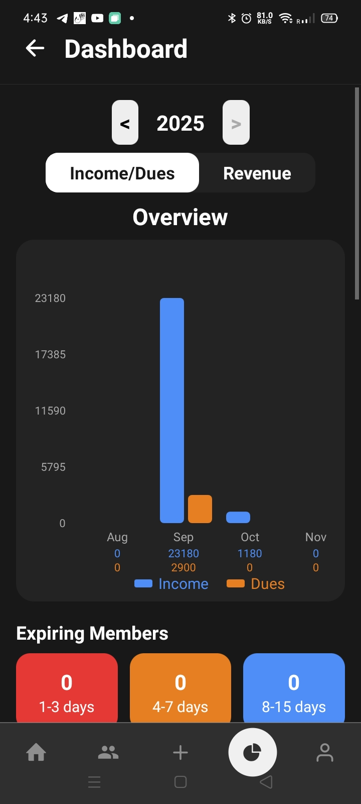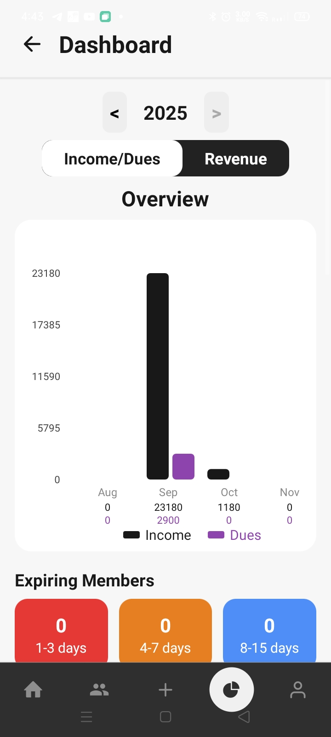

(Screenshot: Dashboard Screen)

A.3 Member Registration Screen
This screen allows the administrator to register new gym members.
Description:
- Input fields for personal and contact details
- Membership plan selection
- Joining date entry
- Validation of mandatory fields
Purpose:
- Centralized member data management
- Eliminates paper-based records

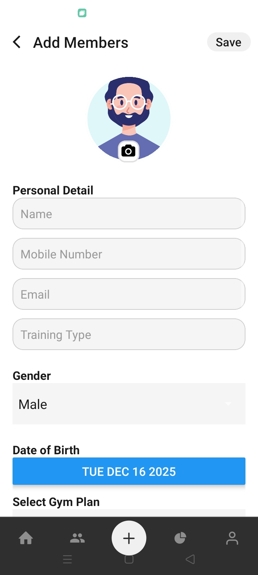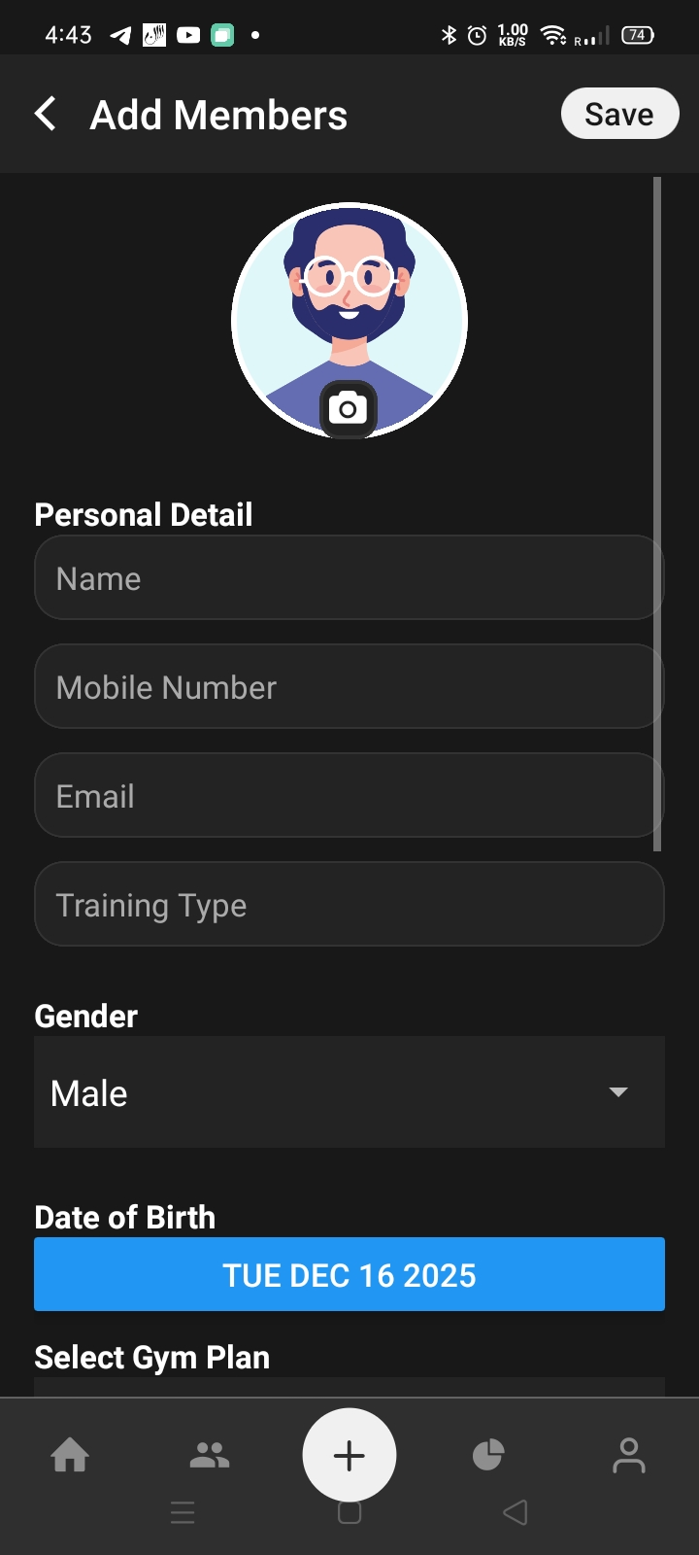

(Screenshot: Member Registration Screen)

A.4 Member Management Screen
This screen displays a list of all registered members and allows modifications.
Description:
- View member details
- Edit existing member information
- Delete inactive members
- Search and filter members
Purpose:
- Efficient handling of member records
- Easy data updates
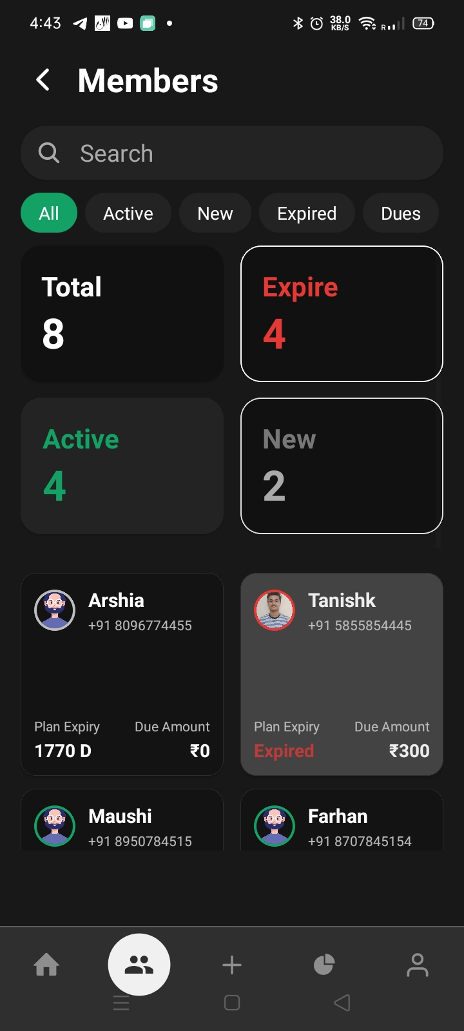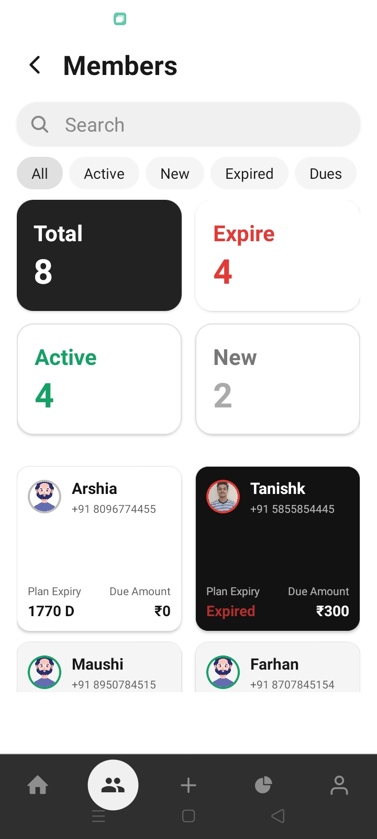

(Screenshot: Member List Screen)

A.5 Attendance Management Screen
The attendance module records daily attendance of gym members.
Description:
- Date selection option
- Member selection
- Attendance marking (Present/Absent)
- Attendance history view
Purpose:
- Accurate attendance tracking
- Generation of attendance reports

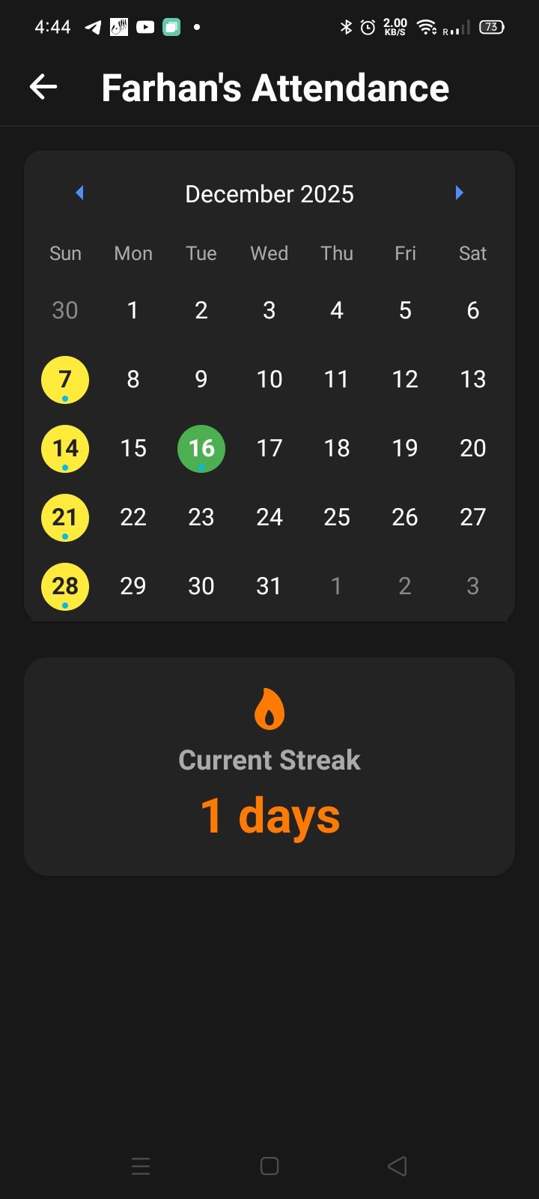

(Screenshot: Attendance Screen)

A.6 Payment and Transaction Screen
This screen handles all payment-related operations.
Description:
- Monthly fee entry
- Automatic due calculation
- Transaction history display
- Payment status updates
Purpose:
- Transparent financial management
- Accurate record keeping

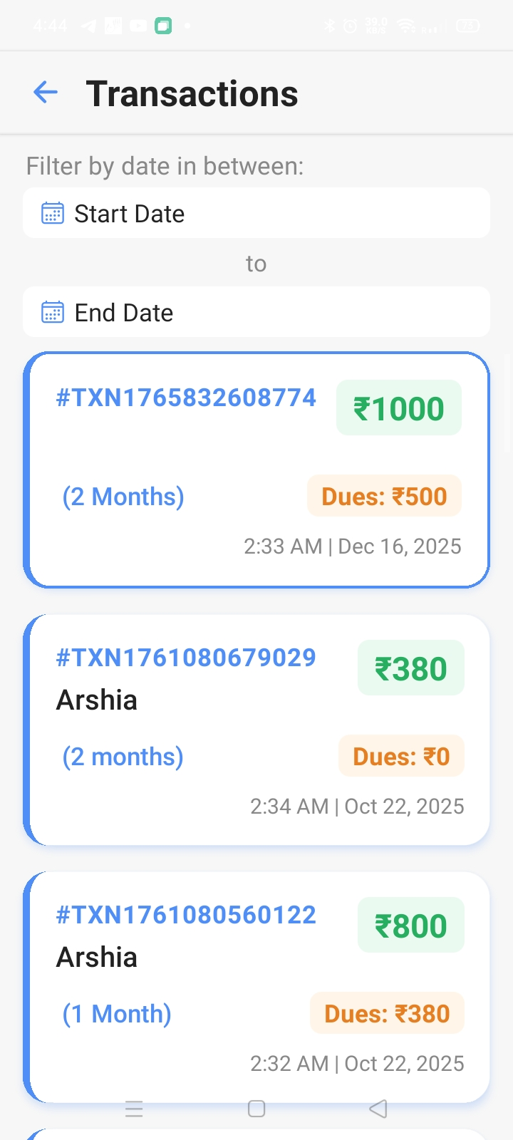
(Screenshot: Payment Screen)

A.7 Membership Plan Screen
This screen manages gym membership plans.
Description:
- Add new membership plans
- Modify plan duration and pricing
- Assign plans to members
Purpose:
- Flexible membership management
- Easy plan customization

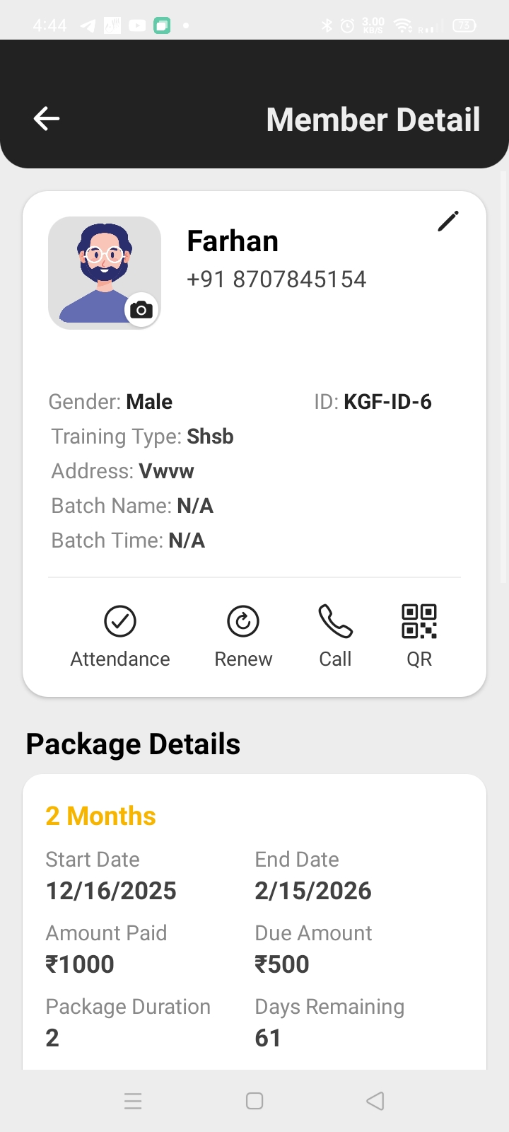

(Screenshot: Membership Plan Screen)

**APPENDIX – II
DATABASE STRUCTURE DESCRIPTION**
This appendix describes the logical database structure used in the Gym Management System.
B.1 Members Collection
Stores personal and membership details of gym members.
Fields:
- Member ID
- Name
- Age
- Gender
- Contact Number
- Membership Plan
- Joining Date

B.2 Attendance Collection
Stores daily attendance records.
Fields:
- Attendance ID
- Member ID
- Date
- Attendance Status

B.3 Transactions Collection
Stores payment-related data.
Fields:
- Transaction ID
- Member ID
- Amount Paid
- Payment Date
- Due Amount

B.4 Membership Plans Collection
Stores information related to gym plans.
Fields:
- Plan ID
- Plan Name
- Duration
- Price

**APPENDIX – III
SAMPLE ALGORITHMS**
C.1 Attendance Recording Algorithm
- Select date
- Select member
- Mark attendance status
- Store record in database

C.2 Payment Due Calculation Algorithm
- Retrieve membership plan
- Check last payment date
- Calculate due based on plan duration
- Update payment status

**APPENDIX – IV
TEST CASE SUMMARY**
Test Case | Description | Expected Result | Status
TC01 | Login validation | Successful login | Pass
TC02 | Member registration | Data stored | Pass
TC03 | Attendance entry | Record saved | Pass
TC04 | Payment entry | Due calculated | Pass

**APPENDIX – V
SUMMARY OF APPENDICES**
The appendices provide additional implementation details, screenshots, database descriptions, algorithms, and test cases related to the Gym Management System. These supplementary materials enhance understanding of the system while keeping the main report concise and focused.

